**Governor Stirling Senior High School**

**Year 12 Physics**

**Task 2: Test 1 – Vectors, Projectiles and Circular Motion**

**Vectors, Projectile Motion and Circular Motion**

**NAME**: __________________________

**TEACHER**:_______________________ **MARKS**: **/40**



* **Answer all questions.**
* **Show all working.**
* **When calculating numerical answers, show your working or reasoning clearly.**
* **Give final answers to three significant figures and include appropriate units.**
* **When estimating numerical answers, show your working or reasoning clearly. Give final answers to a maximum of two significant figures and include appropriate units.**

1. Kelvin and David are playing a game of pool. David strikes the ball with a velocity of 2.4 ms-1, the ball hits the side of the pool table at an angle of 45° and bounces off with a velocity of 2.3 ms-1. Calculate the change in velocity of the pool ball. 4 marks



1. Bianca ties a 50.0 g rock to a 1.40 m long piece of string and swings it around above her head. The string makes an angle of 70.0° to the vertical.

On the diagram draw and label the forces acting on the rock. (2 marks)

Calculate the tension in the string (3 marks)

Calculate the velocity of the rock (4 marks)

1. The Anna Meares Velodrome in Queensland is a banked track used for high speed bike racing. The track is banked at 43.9° to horizontal.

Using a labelled diagram explain how the banked track allows the bikes to travel at average speeds greater than they could on a flat surface. (4 marks)

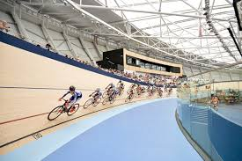

1. To film zero gravity movie scenes, the film cast and crew fly in a large aeroplane travelling in a 300 m arc. Calculate the magnitude of the velocity that the aeroplane needs to fly to achieve the sensation of zero gravity inside the plane. (3 marks)

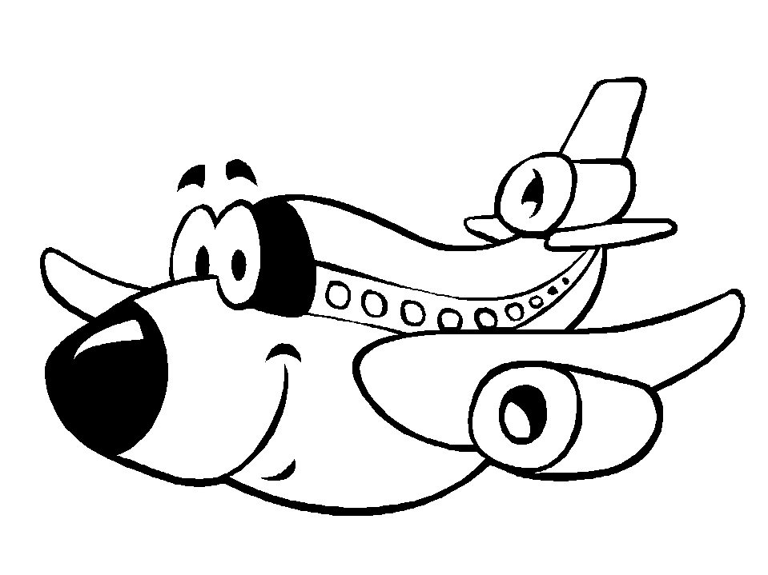

r = 300 m

1. The DNA tower in King’s Park is 15.0 m high.

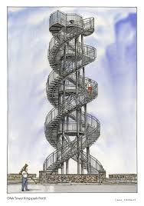

Mr Taylor threw a physics book off the top of the tower with a horizontal velocity of 3.50 ms-1.

Calculate the following: (9 marks)

1. The time taken for the book to hit the ground
2. The distance that the book will land from the base of the tower
3. The velocity that the book hits the ground
4. Ben dropped his shoe off the Willetton J Block balcony while waiting for Mr Johnson to turn up to his Chemistry class. A year 8 student on the ground 5.00 m from the building threw the shoe back to Ben at an angle of 50°. Ben caught the shoe 3.30 m above the throw height.

Calculate the velocity that the year 8 student threw the shoe. (6 marks)

3.30 m

50°

5.00 m

1. Last weekend the Rottnest Island swim took place with hundreds of people competing in a swimming race from Cottesloe Beach to Rottnest Island 19.7 km to the West. There was a current in the water running from North to South at 1.00km/hr. The winning swimmer Sam Sheppard completed the race in 4hours, 11 minutes and 23 seconds.

Calculate the magnitude of Sam Sheppard’s average velocity for the race. (5 marks)

END OF PAPER